Best Foot Forward students inspired by Frida Kahlo at Norton Museum
By ALEX KUSHEL
SUN SENTINEL CORRESPONDENT |
DEC 17, 2021 AT 7:44 AM
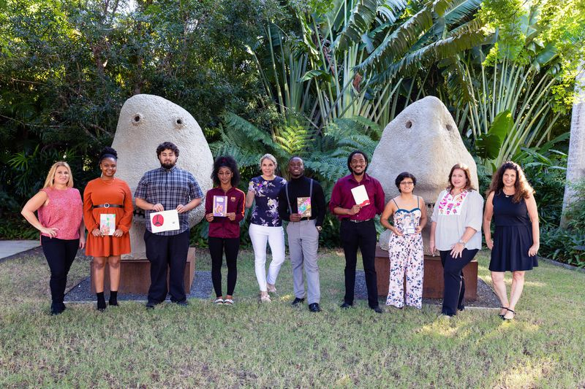
Best Foot Forward students show the art journals they made during a class at the Norton Museum of Art in West Palm Beach. (CAPEHART / Courtesy)
GL Homes recently partnered with Best Foot Forward, a Boca Raton-based nonprofit, to host college-age foster students on a private tour of the Frida Kahlo art exhibit and provide a private art lesson at the Norton Museum of Art in West Palm Beach.
The Best Foot Forward students were led on a private tour of the art exhibit, which featured Frida Kahlo, Diego Rivera and Mexican Modernism. Norton Museum of Art teaching artist Ingrid Sanchez offered private instruction to the students in a workshop room after the tour. The art activity was based on Kahlo’s sketches. The students received colored copies of her sketchbook and decorative paper for designing the cover.
ADVERTISING
Donna Biase, co-founder and CEO of Best Foot Forward, said the students attended the museum for the first time.
“We thought it was an incredible way to expose our kids to some cultural opportunities and everyday life experiences that many students who are in foster care do not get to,” she said. “We are so grateful for the partnership with GL Homes. It’s such an incredible feeling for the kids to be in a beautiful museum like the Norton, and it’s just wonderful. This is not a mandatory part of our program. The students wanted to be here.”
Sarah Alsofrom, GL Homes’ senior director of community relations, said they have teamed up with Best Foot Forward for over four years.

“Art opens the heart and mind to an endless world of possibilities and that is what GL Homes wants to give to these very deserving students,” she said. “Many of us take for granted that we can take our children to museums. Children in foster care and the kids who have aged out quite often do not have those same experiences that our own families have. We are able to bring them to a world-class art museum and it’s opening doors to them and opening their eyes to all the opportunities that are out there. When we are excited about the event and experience, we know the students are as well.”

Best Foot Forward student Victoria Pagan previously painted a Frida Kahlo portrait in 2018, which is displayed in the nonprofit’s office. Pagan started drawing at age 7.
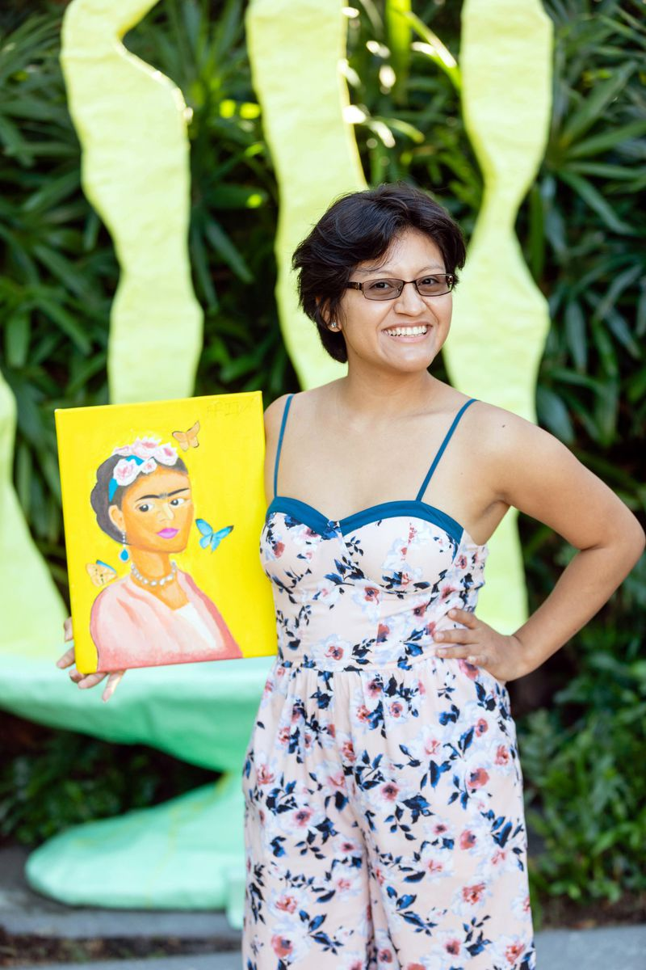
Victoria Pagan said her trip to see Frida Kahlo's work at the Norton Museum was inspiring. (CAPEHART / Courtesy)
“Frida Kahlo represents the unity of my people and traditions, and it was inspiring to me,” Pagan said. “I used to be shy and quiet and feeling lonely until I found my artistic way. Art is a part of me and it’s about finding the reason to do what you love. I was doing it for fame in the beginning and not anymore. I discovered myself as an artist and started to understand it’s about the feeling and being content. I am getting better and falling more in love with art.”
In November, a Kahlo painting was sold for $34.9 million, which set a record for the most valuable work of Latin American art ever sold at an auction.

Pagan said she has also enjoyed building strong relationships with the members of the program.
“The whole team at Best Foot Forward has helped me a lot,” she said. “We feel good about ourselves. They help us in school and with supplies. We go to events. I am with beautiful people and I am thankful. I am grateful because they are family.”
Best Foot Forward student Kayla Espute, who graduated from Palm Beach State College with her associate’s degree this month at age 19, attended an art museum for the first time. She has been with Best Foot Forward since 11th grade.
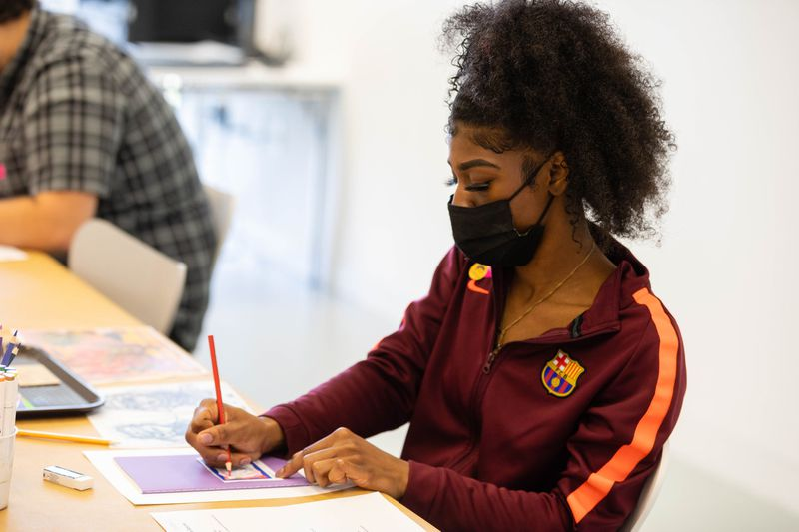
Best Foot Forward student Kayla Espute visited the Norton Museum for the first time recently. (CAPEHART / Courtesy)
“It’s a great experience and so happy to see the works at the art museum,” she said. “I took art appreciation in college and I was interested in the different periods. It’s beautiful here and I want to make it a hobby of mine to go to art museums after this. I was able to meet other Best Foot Forward students in college and that allowed me to have study groups and branch out and explore what they are interested in.”

Best Foot Forward has also provided art lessons for students at the Boca Raton Museum Art School.
“Many of our students had never picked up a paint brush before,” Biase said. “The students are unable to relate because they have not been exposed to this. From our perspective, it’s really neat and an amazing opportunity for the students.”
Best Foot Forward has been a lifeline for foster care students by working to improve education outcomes for students in the foster care system and for those who have aged out. They work to ensure the students receive the same educational opportunities as other children.
“The kids are great and they do not realize how much they have changed our lives,” Biase said. “We have kids who have been with us since elementary school. We have kids who did not go to school until the fourth grade. We had a ninth-grader that could not read. When you first meet with them, they are so anxious. We have been able to watch them grow up and I am in awe to see them have such great communication. It’s an incredible feeling to watch them and really amazing.”

Top of Form
Bottom of Form
The nationwide stats for children in the foster care system who graduate high school is less than 50%. The national college graduation rate for foster youth is less than 3%, according to the National Foster Youth Institute.
Biase said Best Foot Forward has about 250 students in the program from kindergarten to post-college. She noted the program has been able to produce a 100% high school graduation rate for students and 89% graduation rate for students with a college degree. Biase said students have graduated with master degrees and there is a student who works at Veterans Affairs.
Best Foot Forward holds etiquette dinners and career and human resource opportunities. It organizes holiday and back-to-school parties and dinners to celebrate student graduations. Best Foot Forward students who have graduated college also received mentorship from the GL Homes Human Resources team for advice in the workforce.

“We are so thrilled and have so much gratitude for what GL Homes has done for our students at Best Foot Forward,” Biase said. “GL Homes will be recognized as the champion of children at the Best Foot Forward Bash in April, which is our largest annual fundraiser. GL Homes has such a presence in the community and it’s just natural to select them because they help kids and all walks of life.”
Visit bestfoot.org.

Frida Kahlo, Diego Rivera and Mexican Modernism from the Jacques and Natasha Gelman Collection is on view until Feb. 6 at the Norton Museum of Art, 1450 S. Dixie Highway, in West Palm Beach. Visit norton.org.

THANK YOU NOTES:
