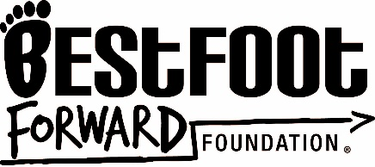
AUTHORIZATION FOR RELEASE OF INFORMATION AND RECORDS

Name of Student: Click or tap here to enter text.
Date of Birth: Click or tap here to enter text.
I hereby authorize Best Foot Forward to meet with and obtain or review the educational records (records, files, documents, and other materials which contain information directly related to the student and are maintained by an educational agency or institution) of the student named above from the Department of Education, any local school board, school district, or their representative.

This authorization is for the purpose of Educational Support, Mentoring & Advocacy.

I understand that this authorization is for repeated access to records from the Department of Education, local school board, school district, or their representative. The confidentiality of the records will be maintained and they may only be released with my written approval.

Signature: Click or tap here to enter text. Date: Click or tap here to enter text.

Print Name: Click or tap here to enter text. Phone Number: Click or tap here to enter text.

Relationship to Student: Click or tap here to enter text.

Best Foot Forward Foundation © 2010 All rights reserved. No portion of this document may be reproduced without the express written permission of the Best Foot Forward Foundation.

