Words of wisdom and winners
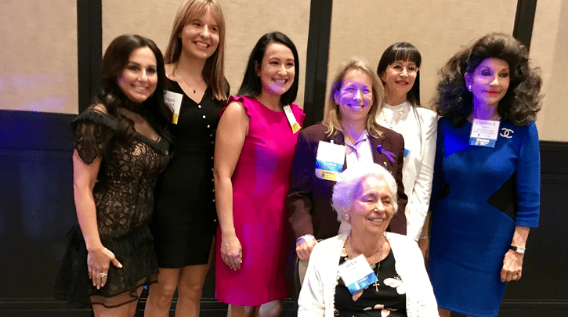
Women of Distinction Award winners, from left, and honorary chair Christine E. Lynn, right, gather around Helen Babione, Lifetime Achievement honoree.
“Everybody can do something for somebody.” Words of wisdom from Helen Babione.
Boca’s enduring altruist received the Lifetime Achievement Award at the Soroptimists’ 29th Women of Distinction Awards Wednesday.
Christine E. Lynn introduced her and read the long list of organizations Babione founded or supports. “That’s just the tip of the iceberg,” said Lynn, board chair of Boca Raton Regional Hospital and Lynn University.
“When Helen asks for help, she isn’t turned down. She has spent her life helping others,” said Lynn, the event’s honorary chair.
“Congratulations to our matriarch,” Dr. Heidi Schaeffer said in her tribute in the program journal.
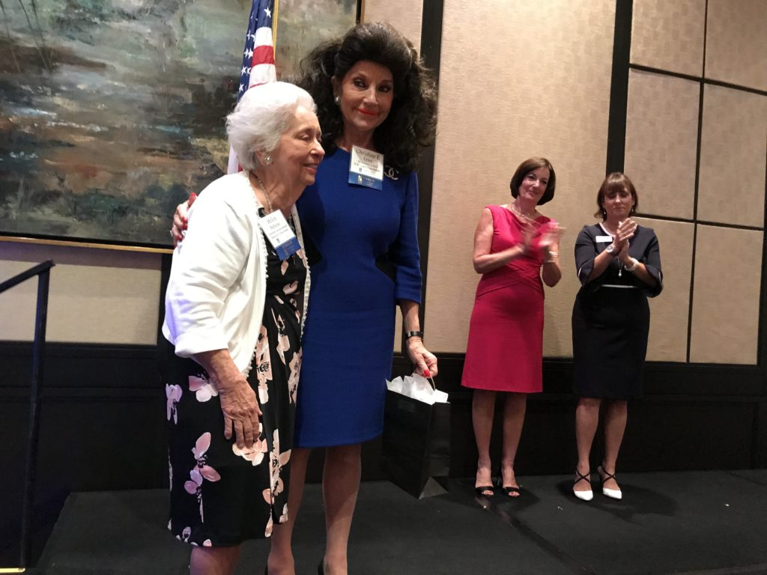
In fact, Schaeffer shared kudos as the honoree in the Outreach category. She was nominated by Soroptimist International Boca Raton/Deerfield Beach. Schaeffer and Lynn were also platinum sponsors of the breakfast. The hospital sponsored a VIP reception and had several tables there.
Lifetime Achievement honoree Helen Babione, left, and Christine E. Lynn on stage at Soroptimist International of Boca Raton/Deerfield Beach. To the right are Terry Fedele, in pink, and chapter president Marybeth Keenan.
The other Women of Distinction winners and their nonprofit nominators were:
· Michelle Adams, Children & Families, Best Foot Forward Foundation;
· Robin Bresky, Community, Legal Aid Society of Palm Beach County;
· Abigail Howard, Education, Florida Atlantic University;
· Patricia C. Collazo, Health, Trustbridge Hospice
Terry Fedele and Jennifer Thomason co-chaired the breakfast, a Boca ritual that kicks off high season. Paige Kornblue emceed the event in Boca West Country Club.
“Last year, Soroptimist supported 26 nonprofits; give $20,000 back to the community and $6,000 in scholarships,” Thomason told 250 people.
Soroptimists are volunteers who rely on donations to support girls and women with grants, mentoring, training and scholarships.
By Marci Shatzman

