Home Boca Raton Soroptimists honor Boca’s Helen Babione with Lifetime Achievement Award
Soroptimists honor Boca’s Helen Babione with Lifetime Achievement Award
October 28, 2019

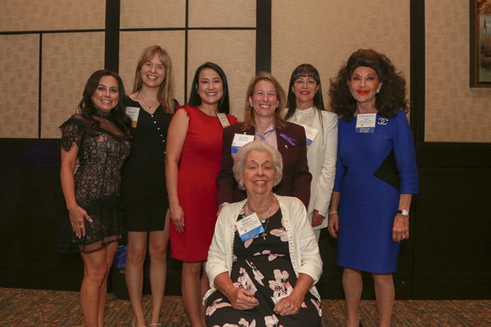
By: Dale King Contributing Writer
As a successful Boca Raton businesswoman, philanthropist, civic leader and supporter of local charities for a half-century, Helen Babione has rightfully earned a reputation for compassion, grace, empathy and charm, with a special heartfelt admiration for the community she adopted as her home in 1960.
She has never hesitated to speak her mind about the causes she supports. But when it came time to accept a Lifetime Achievement Award from Soroptimist International of Boca Raton/Deerfield Beach at its Women of Distinction 46th Annual Awards Breakfast last month, she was momentarily wordless.
“I’m not used to making speeches,” Babione said in a soft voice from the podium at Boca West Country Club, overlooking an audience on its feet and applauding loudly for the woman with a proven community track record.
“It’s wonderful to see so many people,” she said, taking in the enormity of the situation.
Hundreds packed the West Boca venue for the 46th yearly gathering of Soroptimists – a group whose mission is to improve the lives of women and girls through programs leading to social and economic improvement.
“This is our signature fundraiser,” said event co-chairs Terry Fedele and Jennifer Thomason. “Money raised by this event are distributed to various local charities serving women and children and also provide scholarships for women who are trying to continue on an educational path that will improve their livelihood.”
The women’s organization split the breakfast event’s agenda between honoring its Women of Distinction and presenting Babione with her accolade.
Another noted Boca Raton charitable donor and Soroptimist member, Christine Lynn, took the floor to introduce her friend, Helen Babione, who fought back tears as Lynn heaped praise and tributes upon her.
Lynn said she took on the task of being the event’s honorary chair “because it was for Helen.”
She went on: “Is there anyone active in South Palm Beach County who does not know Helen Babione?” Lynn asked. “More than 50 years ago, she was a founding member of our Boca Ra-ton/Deerfield Beach Chapter of Soroptimist International in which she held numerous leadership roles – including president and board member.”
After living in Lake Worth for 12 years, Helen Babione moved to Boca Raton in 1960 where she and her husband, Robert, opened Babione Funeral Home.
Seeking to serve local civic groups, she became active with the communities in and around Boca Raton. Helen is a half-century member of the Women’s Club, a life member of the Debbie Rand Memorial Service League and member of the Caridad Center. She is also a founding member of both Horses and the Handicapped and the Society for the Disabled. She has also co-chaired the Go Pink Luncheon for Boca Raton Regional Hospital for many years.
She still works as a funeral home consultant.
As to the Women of Distinction presentation, 26 nominees were selected in five categories. Each group was called to the podium where one winner was chosen from each assemblage.
Michelle Adams was selected by judges as winner in the Children and Families category for her participation in the group, Best Food Forward. Other nominees in that classification were Rosie Inganzo-Martin, Pat McCarthy, Jennifer Rey and Nicole Roman.
Robin Bresky, a member of the Legal Aid Society of Palm Beach County’s Board of Directors for 12 years, took the top spot in the Community category. Others judged in that division were Jennifer Jager, Debbie Langson, Jan Savarick, Crystal Spears and Lina VaLant.
Abigail Howard, a 21-year-old criminal justice major at Florida Atlantic University, and who founded her own nonprofit organization, Project Micah 6:8 at age 18, took the lead award in the Education category. Also vying for that honor were Donna Korn, Lisa Rabinsky and Seton Smith.
In the Health division, Patricia C. Collazo, a volunteer at Trustbridge Hospice, took first place honors. Also in the running were Meryll Bangsil, Kim Champion, Mara Murphy and Fran Nachlas.
Soroptimist International notched a win when judges chose SI member Dr. Heidi Schaeffer. She serves as District 1 director overseeing eight clubs from San Juan to Homestead. She is also chair of Southern Region’s Human Trafficking Committee where she has successfully lobbied for vic-tim-centered policy/legislation.

