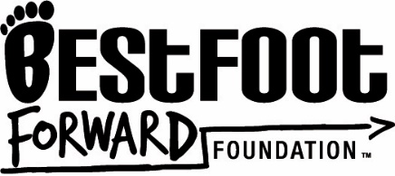
AUTHORIZATION FOR RELEASE OF INFORMATION AND RECORDS

Name of Student: ___________________________
Date of Birth: _______________________________

I hereby authorize Best Foot Forward to obtain or review the educational records (records, files, documents, and other materials which contain information directly related to the student and are maintained by an educational agency or institution) of the student named above from the Department of Education, any local school board, school district, or their representative.

This authorization is for the purpose of Educational Mentoring/Advocacy.

I understand that this authorization is for repeated access to records from the Department of Education, local school board, school district, or their representative. The confidentiality of the records will be maintained and they may only be released with my written approval.

__________________________________ __________________________
Signature Date

__________________________________ _________________________
Print Name Phone Number

__________________________________
Relationship to Student
Best Foot Forward Foundation © 2010 All rights reserved. No portion of this document may be reproduced without the express written permission of the Best Foot Forward Foundation.

