Published On: Wed, Oct 10th, 2018
Robert's Community Report | By Robert Weinroth

AT&T Makes $850,000 Grant to ChildNet to Help Children in Foster Care Succeed
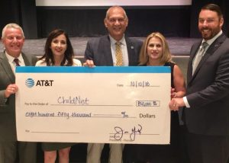
By Robert S Weinroth
It was a day to celebrate the collaboration between our business community, non-profit agencies and our school district to help students reach their full potential.
An $850,000 contribution from AT&T to ChildNet will help local foster care youth succeed in school. ChildNet is among 10 recipient non-profits, nationwide, to share in a grant by AT&T of $9.25 million in celebration of the 10-year anniversary of AT&T Aspire, an initiative to help provide access to education and training students need to get and keep good jobs.
ChilNet is the lead child welfare agency for Palm Beach and Broward counties. $750,000 of the AT&T grant will be used to expand it Grounded for Life academic mentoring program, a collaboration with Best Food Forward (PBC) and Children’s Harbor (Broward).
Over 60% of the children who age out of the foster care system fail to receive a high school diploma. The Grounded for Lufe program is s powerful counterbalance to a childhood often filled with abuse and neglect.
ChildNet will use $100,000 of the grant to create an Educational Services Specialist position in West Palm Beach who will serve 300 students placed in Palm Beach County’s foster care system to help them overcome barriers to success in school.
Over the past 7 years, AT&T has contributed over $1.6 million to ChildNet to help improve educational outcomes for the students it serves.
