Gala nets support for foster children's education
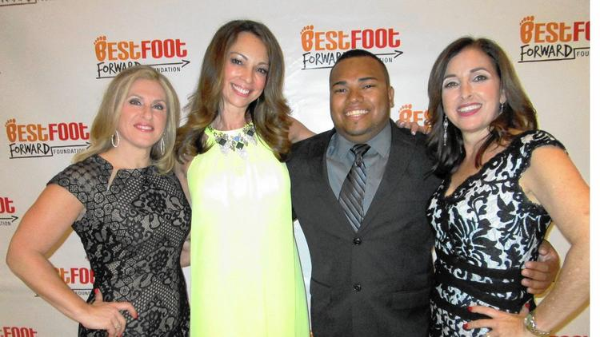
At Best Foot Forward’s BFF Bash were, from left, Donna Biase, emcee WPEC-Ch.12 news anchor Liz Quirantes, David Sarris and Debbie Ellman. (Marci Shatzman/Staff / FPG)
Marci Shatzman mshatzman@tribpub.com
Group hug for Best Foot Forward
Best Foot Forward co-founders Debbie Ellman and Donna Biase received an outpouring of support at their seventh BFF Bash.
The foundation has helped 130 foster care children get the education they want and deserve, emcee and WPEC-Ch. 12 news anchor Liz Quirantes said at the April 9 event in Polo Club Boca Raton.
Proceeds with auctioneer Jason Alpert fund raising exceeded $200,000, Ellman said.
"We have figured out how to break the cycle" of neglect and abuse, she told the 400 people who attended. "Only 46 percent of children in foster care graduate and only 3 percent go to college. If you can level the playing field with education, that's how you change a life."
Seventeen young adult foster children were there from the program.
David Sarris told his story.
"I came into the foster care system at 14 and aged out at 18 and was living on my own..." until he got involved with Best Foot Forward, he said.
He graduated from Palm Beach State College.
"I wanted to drop out along the way but Debbie and Donna wouldn't let me," he said.
With an IT degree, he was lured by job offers. But BFF encouraged him to keep going, so now he's earning a social work degree at Florida Atlantic University.
"I am absolutely loving FAU because I'm in a better place now with my goal to help kids in the foster care system," he said.
But then he said he started losing his vision and "didn't want to bother Debbie and Donna with my problems."
BFF stepped in again, and his eye doctors were at the gala.
The presenting sponsor was The Lisa J. Leder Family Foundation, and Leder presented an additional scholarship for books and incidentals. Major support also came from Marleen Forkas, Sun Capital Partners Foundation and 48 other sponsors, Biase said.
The entire board of directors turned out, she said, including president Paul Kilgallon, J.C. Perrin, school board vice chairman Frank Barbieri, Lorraine Cross, Jennifer Jager, Marjorie Margolies, Lisa Wheeler and Sherry Morganstein.
Executive director Larry Rein was introduced from ChildNet, the state-sanctioned lead agency to protect abandoned, abused and neglected children in Broward and Palm Beach counties.
Event chairwomen for the last five years were Cheryl Cherney and Kathy Feinerman with Christine Werking joining them this year.
"Every year they bring us to another level," Biase said.
Copyright © 2016, Sun Sentinel

